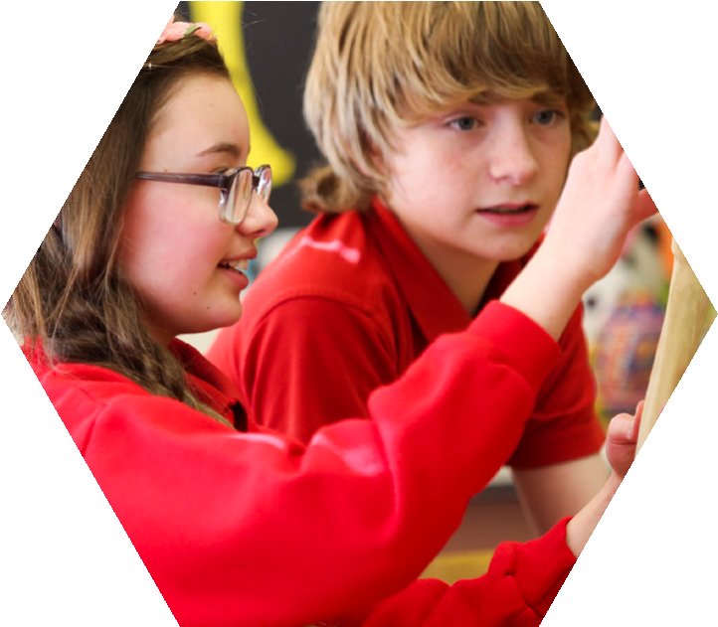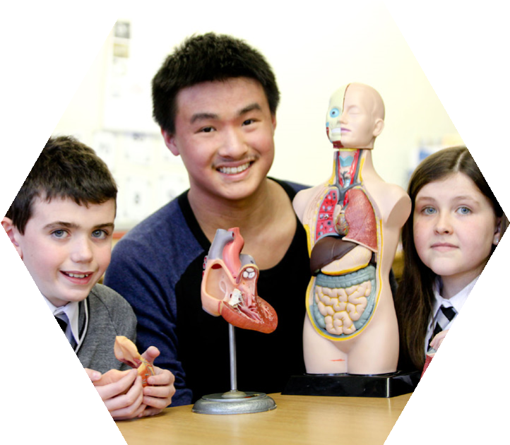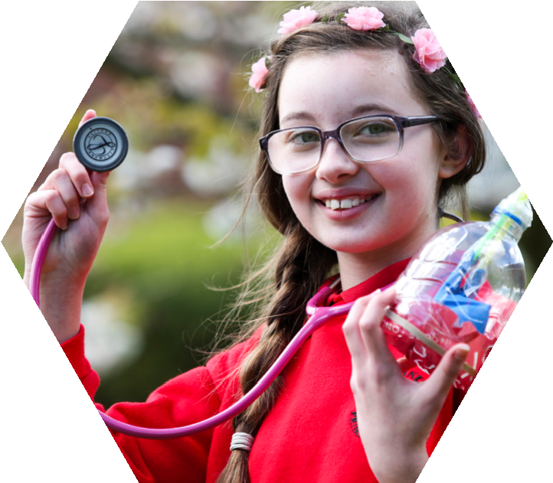
Medics in Primary Schools
A QUEEN’S UNIVERSITY / SENTINUS PROGRAMME
Personal Logbook
In-school version

BACKGROUND INFORMATION
Name of Teacher
Class
Number of Pupils | Boys | Girls | Total
Relevant pupil information
for example, ability range of pupils
Social background of pupils
Neighbourhood of school
How does this school compare with your own experience at primary school?

TRAINING SESSION
Following the Training Session my understanding of what I have to do in my first unit is:

My feelings about how I will progress through the first unit are:
My feelings about the Training Session are:

SCHOOL INTRODUCTION SESSION
Following the School Introduction Session my first impressions of the school and its pupils are:

What positive impressions have I gained from my visit to the school?

What apprehensions do I have?

What ideas do I have about how I might work with these pupils?

My feelings about the School Introduction Session are:

HEALTHY BODY
What did I learn about the pupils’ knowledge of this topic?

What did the pupils experience / learn as a result of our work on this topic?

How well did I communicate with the pupils?

What are my overall impressions of this topic?
(For example, how valuable / worthwhile for myself / pupils, how interesting, how well was the work pitched at an appropriate level for the children, etc)

In what way(s) can I improve the way I work with the pupils?

What feedback did I receive from my class teacher?

The student has successfully completed this unit
Signed:
Class Teacher:
Date:

HEALTHY BREATHING AND CIRCULATION
What did I learn about the pupils’ knowledge of this topic?
What did the pupils experience / learn as a result of our work on this topic?

How well did I communicate with the pupils?

What are my overall impressions of this topic?
(For example, how valuable / worthwhile for myself / pupils, how interesting, how well was the work pitched at an appropriate level for the children, etc)
In what way(s) can I improve the way I work with the pupils?
What feedback did I receive from my class teacher?
The student has successfully completed this unit
Signed:
Class Teacher:
Date:

ON COMPLETION OF THE PROGRAMME
How have the pupils’ responses to me changed during the programme?

How have my overall communication skills improved during the programme?

What are my overall impressions of the programme?

What were the class teacher’s observations of my work?
What skills have I acquired during the programme which I think will be useful in my future career?

Has the training I received in communication skills during my course been useful for this module?

Signed:
Student:
Date:
Significant events

List here events which were surprising, pleasantly or otherwise, unusual or completely unexpected. Please note these down at the time, as you may not remember them when you come to prepare your commentary.

Week | Date | Event
Introduction

Week 1

Week 2

Week 3

Week 4

Week 5

Week 6

Week 7

Week 8

Week 9

