Medics in Primary Schools 2022
9
Healthy Skin

Please discuss this guidance material with your class teacher before starting this unit, particularly in relation to practical activities, and act on her / his advice.

Healthy Skin is unlikely to have been covered in class. Work on the assumption that most of this material is new to pupils. This unit can contribute to Personal Understanding and Health, which is part of the Northern Ireland Curriculum’s area: Personal Development and Mutual Understanding (PD&MU). For more information on this aspect of the primary school curriculum, see http://ccea.org.uk, follow Curriculum, then (drop down) Key Stage 1&2, then Personal Development and Mutual Understanding. The material can also be used as appropriate to develop pupils’ cross-curricular capabilities in Communication, Using Mathematics, and Using ICT (Information and Communication Technologies).

Week 1

1. What is skin?
2. What does it do?
Pupils should learn:
- the structure of their skin, including its basic components
- the purpose of each component of their skin

*Check in advance if the school has these resources:
- lenses (+20D, if available) or hand magnifier
- Sellotape (for skin peeling)
- "head" and other types of thermometer
- (if available) temperature sensors and computer
- microscopes

Activity – Investigating my skin
The theme should be developed through your questioning of the children. Ask pupils to look at their own skin (or a Sellotape peeling) through a lens (and microscope if available). The Sellotape peeling is made by sticking a piece of Sellotape to the pupil’s fingertip and removing it (an impression of the pupil’s finger print should be seen). Ask them to draw and describe what they see. You may find Activity Sheet B12: Magnification useful here to get across the idea of magnification.

Activity – Skin temperature
*You will need appropriate thermometers for this activity.
Ask pupils to find out the temperature of their skin. How does this compare with the temperature of the air around them? Probably about twenty degrees warmer. What are the implications of this? There is a loss of heat energy from the (warmer) body to the (cooler) air, so there must be a source of energy inside the body (from food and oxygen), and a means of insulation, which can be within the skin (fat) or outside (clothes). This can be linked to the nutrition section of the Healthy Body unit.

Activity – Skin Structure
Develop on the board a diagram of the skin (which should be similar to the diagram below) from pupils’ answers to questions. Also encourage the pupils to ask you questions. Do not show the diagram or website as a first step. Alternatively you might use www.abpischools.org.uk/topic/skin-structure-and-function/5/1 Invite pupils to come to the interactive whiteboard to drag labels of the structures of the skin to appropriate blanks. You can also explain the function of the different structures while the pupils perform this activity.

The diagram on page 2 of the ABPI web resource above can be used at the end of the topic for consolidation or revision. Pupils need not remember the diagram, but they should understand the relationships between components. You may use Activity Sheet B14: Labelling Skin here

Pupils should know that our skin includes the following components:
(1) surface (epidermis),
(2) soft tissue (dermis),
(3) hair and oil glands,
(4) sweat glands,
(5) nerves,
(6) blood (arteries > capillaries > veins), and
(7) fat
(Terms in brackets above should be discussed, but not necessarily to be remembered by pupils)

Components (parts) of your skin are (A) hair, (B) dead skin flakes, (C) opening of sweat duct (pore), (D) surface layer,
(E) nerve receptor, (F) oil gland, (G) capillaries, (H) sweat gland, (J) nerve, (K) artery, (L) fat, and (M), vein

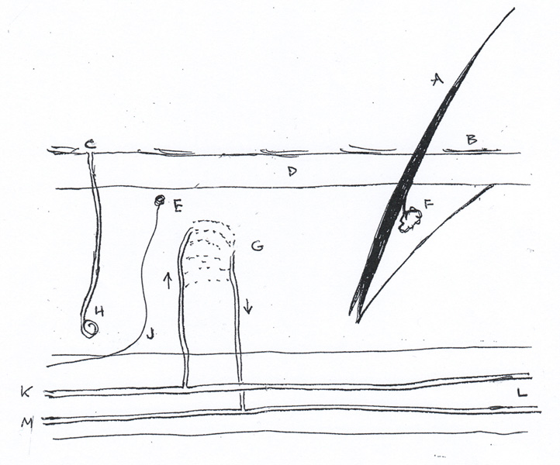

Ask the question: What is each component for?
Pupils should understand the operation of each of these components in relation to
(1) temperature control,
(2) heat insulation,
(3) energy storage,
(4) sense of touch,
(5) protection from harm, and
(6) keeping water and other unwanted materials out of their body

Not all of the objectives will be achieved during the first day. Some may be covered at appropriate points later, in relation to dangers to the skin.

You may find the following websites useful:
- British Association of Dermatologists www.bad.org.uk/patient-information-leaflets for information on professional leaflets and presentations on skin, which can be downloaded for your own background information. Note that these are designed for you as a health professional, not directly for pupils.
- ABPI: the Association of the British Pharmaceutical Industry www.abpischools.org.uk Follow all Topics, then scroll down the Topics column to Skin Structure and Function This is written for Key Stage 4, but edited material can be used at primary level.

You will find useful information for other areas of MIPS on the ABPI website.

Week 2

3. How can we protect our skin, and keep it healthy?
Pupils should learn:
- about potential dangers to their skin
- how they can be protected from these dangers

Note: this should not be regarded as a first aid session, as most schools have their own policies and procedures on first aid.

Activity – Skin under attack
Ask each pupil to list four things that can attack their skin. Then ask them, in small groups and finally as a class, to develop a more comprehensive list. This should include
(1) chemicals and allergens,
(2) germs / bacteria / viruses / fungi
(3) dirt, which may contain germs and dangerous chemicals
(4) sharp objects
(5) insect and animal stings and bites
(6) wind, dryness, and air and water pollution
(7) excessive sun exposure

Activity – Save our skin
Divide the class into small groups of three or four, and allocate one of the dangers 1 – 6 (and any others provided by the class) to each group. Ask the groups to find out (i) how the danger can attack their skin, (ii) how to prevent damage, and (iii) what to do if their skin is damaged. After 5 – 10 minutes, ask each group to report on at least one aspect of their investigation. Treat danger 7 (excessive sun exposure) separately using the resources in section 4 below.

You can use this type of reporting back activity in other units

Extension Activity – Stings and grazes
You might find the BBC material Bites and Stings useful here: www.bbc.co.uk/teach/class-clips-video/pshe-ks2-bites-and-stings/zxnxqfr. Emphasise means of protecting your skin from these dangers: the importance of hygiene and skincare, bathing and hand washing, protective clothing when necessary, safe handling of tools and chemicals.

Discuss what happens when you cut or graze your skin: the importance of washing the wound and covering it to keep out dirt and germs. Suggest that if they have a recent wound, they keep a diary (with drawings) of what happens as the wound heals, and the scab falls off.

Activity – Effective hand washing
Covid-19 experience emphasies the importance of effective hand washing. *Glo Germ units for the assessment of hand washing technique are useful here. Pupils apply gel to their hands, and then put their hands under the ultra-violet lamp. The unwashed parts of their hands, where bacteria may exist, glow in the ultra-violet light. The pupils then wash their hands and repeat the exercise. On the second occasion the amount of bacteria is reduced (but probably not eliminated).

Glo Germ equipment is available for use by students during this module. Details about resources and booking procedures can be found on the module page on Queen’s On Line.

There is useful resource material on effective hand-washing techniques on www.glogerm.com. Click on Education, then (dropdown) School Worksheets. USA Grade 6 is about the middle of our KS2. MIPS Activity Sheet B13: Saving my skin may be useful here for consolidation and revision. The Government guide to effective hand washing is available at www.yas.nhs.uk/media/3142/detailed-handwashing-poster.pdf

4. How can we protect our skin from the sun, and keep it healthy?

Identify means of protecting the skin form dangers associated with the sun. *You can find several useful resources in the following website:
- www.careinthesun.org, managed by Cancer Focus Northern Ireland. Follow Resources, then Schools. This has downloadable resources, including teachers’ guides, background information and statistics, as well as activities for children.

5. What else can we find out about our skin?

If you have time, other possible topics include: plastic surgery, aging, acne and eczema, fingerprinting. Use your expertise or enter these words or phrases into an internet search engine for more information and ideas.

Activity – Good habits: Personal hygiene
Personal hygiene is how you care for your body and maintain good health. Ask pupils individually to list three good hygiene habits. Then ask them to come together in groups of three or four to build up a larger list. Then build up a final list on the board. Some examples include:
1. Washing your hands after returning from outside, and before every time you have food
2. Bathing daily and combing your hair
3. Brushing your teeth twice daily
4. Clipping your nails periodically
5. Covering your mouth while coughing or sneezing
6. Changing your underclothes daily

Developing cross-curricular skills in Healthy Skin

Communication:
- using scientific words and phrases related to the units, for example, nerves, blood, insulate, thermometer, degrees Celsius, room temperature, body temperature.
- making posters to illustrate, for example, protection from the sun
- reporting on investigations, using a range of media including paper, electronic, verbal class presentations

Using mathematics:
- accurate thermometer reading,
- drawing tables and appropriate types of graph
- estimating the magnification of a lens

Using ICT:
- sensor measurement of temperature (if available),
- word processing and presentation of information,
- accessing information on websites, and choosing appropriate material

Notes

